Pennine Lung Service
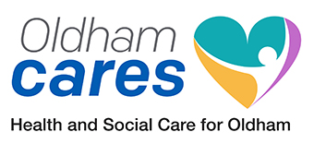
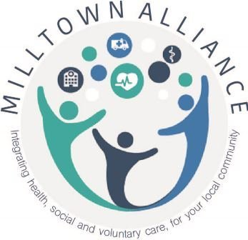

Tel: 0161 627 8522

POST DIAGNOSIS EDUCATION SESSIONS

Dear __________________________

Health Care professionals across Greater Manchester are looking for ways to improve the care and the service for people, like you, who have a diagnosis of COPD.
It is very important that all people diagnosed with COPD have access to a quality education programme delivered locally by respiratory specialists.
The aim of the programme is to help you to understand what COPD is and what it means to you and to your life. The sessions will also focus on:
- What you can do to limit its impact now and slow its progression
- How to manage your care and your health
- How to feel in control of your health and wellbeing
The sessions will take place at:
Link Centre, 140 Union Street, Oldham, OL1 1DZ.
Please use this letter as you would an outpatient letter if you need to agree time off work to attend.
Date: Thursday 19th March 2020 Date: Thursday 26th March 2020
Time: 16.45- 19.30 Time: 17:00- 19.30

Royton Health and Wellbeing Centre, Park Street, Royton, Oldham, Greater Manchester, OL2 6QW
Please use this letter as you would an outpatient letter if you need to agree time off work to attend.
Date: Thursday 14th May 2020 Date: Thursday 21st May 2020
Time: 16.45- 19.30 Time: 16:45- 19.30

The Education Sessions are a vital stage in your care journey. Each one will be very different so it is important that you attend both if you can sessions at your preferred venue. We will contact you around a week before the sessions start to check if you are attending.
If you would like to bring along a partner, friend, relative or carer who may help you to manage your condition please feel free to do so.
This approach is a Pilot and we are very keen to see how to provide it in the future. We are really keen to have your input and evaluation of what went well or not- venues, times of sessions and timings following diagnosis. You will receive a satisfaction questionnaire after the event so we can understand your important view of the session.
This pilot and your feedback will help to shape the future of education programmes not just across Oldham but for the whole of Greater Manchester.
Please contact us on 0161 627 8522 or email us at pah-tr.lungadvice-oldham@nhs.net if you are interested in attending one of the programmes above. We are looking forward to hearing from you.
When contacting us please state which venue of the two venues above you would like to attend so that we can put your name on the relevant list.
For further information please contact Pennine Lung Service on the number above.

The Pennine Lung Service

